## PromoSapien

Keep 17 oz Vacuum Insulated Stainless Steel Bottle, 18/8 Stainless steel construction, double wall insulate, keeps beverage hot or cold for up to 12 hours, screw-on rubber-seal cap. Hand wash only. FDA certified. Complies with CPSIA, FDA, Prop 65. 10.0" H x 2.75" Diameter

For 300: Setup: C$70 for 1 colour; C$120 for multi-colour. Price per unit C$14.87 for 1 colour. extra colour, add $0.93**.** Shipping: C$70

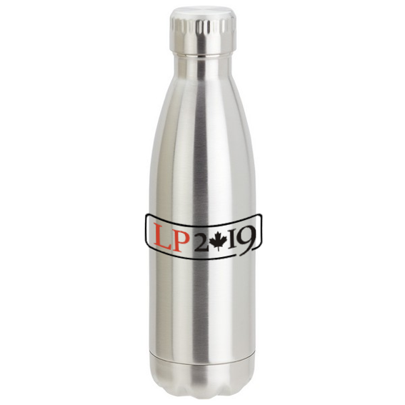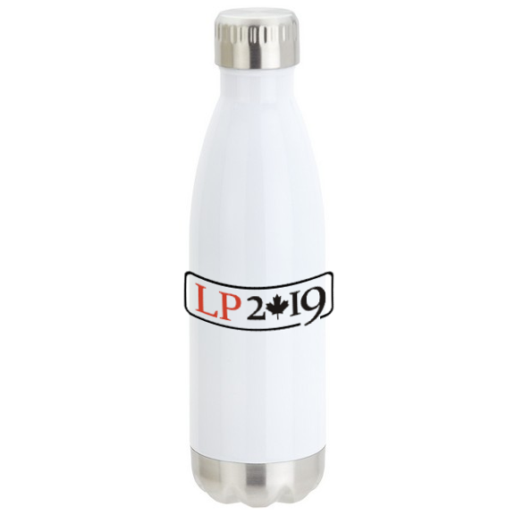

<https://www.promoplace.com/promosapien/p/CJDXL-LJFGU/keep-17-oz-vacuum-insulated-stainless-steel-bottle>

## 4Imprint

**Rockit Claw Stainless Water Bottle - 17 oz.**

• This durable bottle is made of double-wall 18/8 stainless steel for long-lasting use.

• Double wall enclosure stops condensation from building on the outer wall.

• The bottle features vacuum insulation and an inner copper insulated liner for superior freshness and temperature retention.

• Threaded, screw-on stainless steel lid creates a tight seal to prevent spillage or leaks.

• Available in a variety of stylish solid-coloured options.

• This bottle is also available in Wood Grain (#[C135220-WGRockit Claw Stainless Water Bottle - 17 oz. - Wood Grain](https://www.4imprint.ca/product/C135220-WG/Rockit-Claw-Stainless-Water-Bottle-17-oz-Wood-Grain)) and Stone Grey (#[C135220-SGRockit Claw Stainless Water Bottle - 17 oz. - Stone Grey](https://www.4imprint.ca/product/C135220-SG/Rockit-Claw-Stainless-Water-Bottle-17-oz-Stone-Grey)).

• Great for hot or cold beverages!

• Size: holds up to 500 mL (17 ounces).

For 300: Setup: C$55. Price per unit C$11.78. Maximum number of imprint colours: 1

Quote in progress.

## PCNA

**Thor Copper Vacuum Insulated Bottle 17oz**

Durable, double-wall stainless steel vacuum construction with copper insulation, which allows your beverage to stay cold for 48 hours and hot for at least 12 hours. The construction also prevents condensation on the outside of the bottle. Features on-trend, durable powder coating. Stainless steel, screw-on, spill resistant lid. Fits most standard car cup holders. 17oz.

For 300+, $16.52 per unit. Setup fee included. Shipping: $61.18.

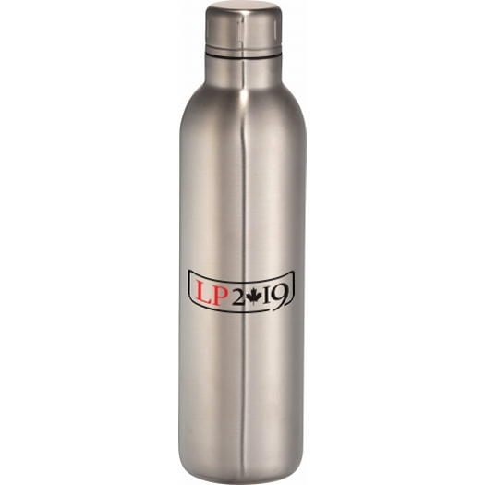

<https://www.pcna.com/leeds/en-ca/leeds-drinkware-sportbottles/product/1626-37_reg?catpath=leeds-categories.1.3.1>

**Supernova Gradient Vacuum Insulated Bottle 14oz**

Part of the Fade Away Trend Collection. Double-wall vacuum insulated construction, 18/8 GradeStainlessSteel keeps drinks hot for 5 hours and cold for 15 hours. It also includes a leak-proof, screw-on lid including a metal, easy-carry loop. On-trend gradient finish. 14oz.

For 300+: $14.80 per unit. Setup fee included. Shipping: CAD$60.60.

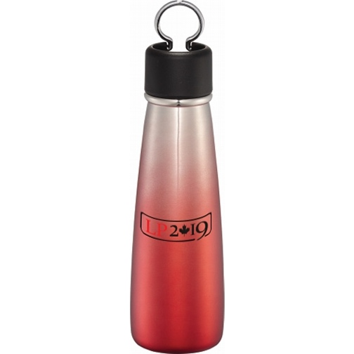

<https://www.pcna.com/leeds/en-ca/leeds-drinkware-vacuuminsulatedbottles/product/1626-43_reg>

## Debco

**500 ml (17 oz.) STAINLESS STEEL WATER BOTTLE WITH CARABINER**

7.5” H x 2.875” Diameter   
• Stainless steel   
• Holds up to 500 ml (17 oz.)   
• Matching coloured carabiner   
• Safe alternative to plastic for your health and the environment   
• Black plastic twist off cap   
• BPA free (Bisphenol A) and FDA Compliant

For 300+, $6.47 per unit. Setup fee included. Shipping: $72.59.

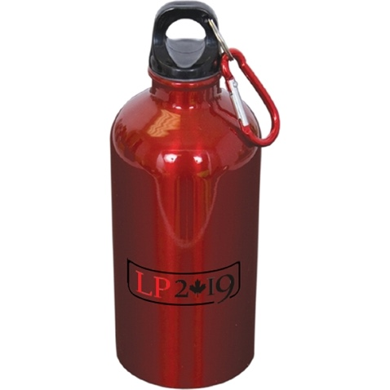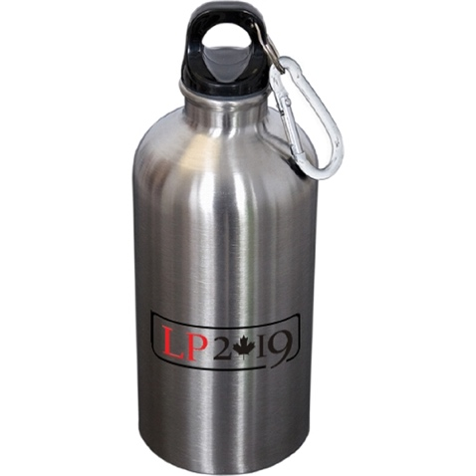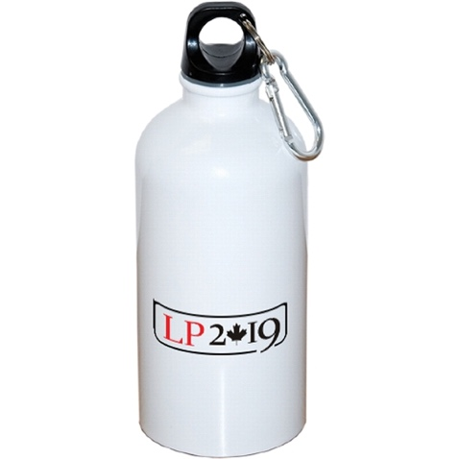

<http://www.debcosolutions.com/EN-US/categoryredirect.aspx?categoryid=WB4833&pricing=CAD&fromCategory=TRUE&flyerFileGUID=6215b5b8-251c-4b2c-a8bf-c788b786c0ce&flyerFileEXT=png>

## 4imprint

<https://www.4imprint.ca/metal-water-bottles>